CYBOTS
ANNUAL REPORT OF 2021-22

CYBOTS, the robotics club of SCTCE, formed by students interested in the field of robotics and latest advancements in the robotics. Founded by the students of 2015-2019 Electronics and Communication batch. It comprises students from all the years and works under the department of Electronics and Communication. It aims to guide and mentor students who are interested in the field of robotics, encourage their participation in inter and intra college level robotic competitions.

ACTIVITIES

- FACTLY

Factly is an online series which conveys information on the latest technology and innovations.
The series has done various posts on the topics
1. Metaverse
2. NFTs
3. Blockchain and its Applications
4. Quantum Computers
5. Holoportation
More posts will be updated in the cybotsinstagram page in the future.

- EMBEDDED SYSTEMS IN ROBOTICS

The webinar on “Embedded systems in robotics” was held on 23/01/2022, Sunday at 7 PM.
The session was conducted by Mr. Anand S who is an Embedded System engineer and was coordinated by Anugraha&Adarsh. Event was attended by 76 students of both SCT College and other colleges together. The webinar brought light into certain basic processors like raspberry pi, differences between a microcontroller and a microprocessor, it was followed by a Q &A session, in which a question that was highlighted was, when will India start the production of its own processors? The meeting ended with a Thank You note by Anugraha. Certificates were issued by mail on 28/01/2022.

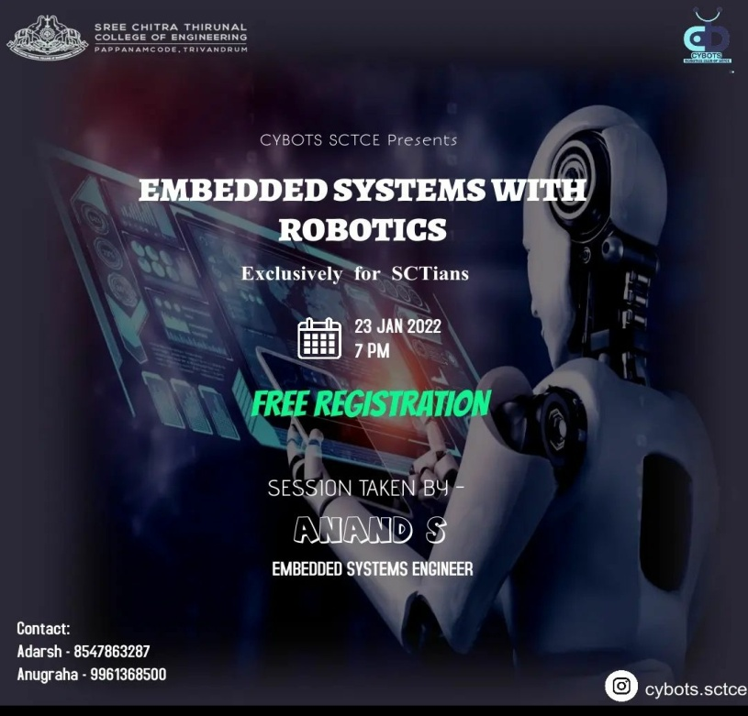

- WIRE YOUR WAY

The webinar on “Wire Your Way” was held on 02/02/2022, Wednesday at 7 PM. The session was conducted by Govind S Nath who is a fourth-year student of our college and was coordinated by Aswin&Rohith. Event was attended by 59 students from our college. The webinar was about circuit designing using Proteus software, it was followed by a Q &A session. The meeting ended with a Thank You note by Rohith. Certificates were issued by mail on 04/02/2022.
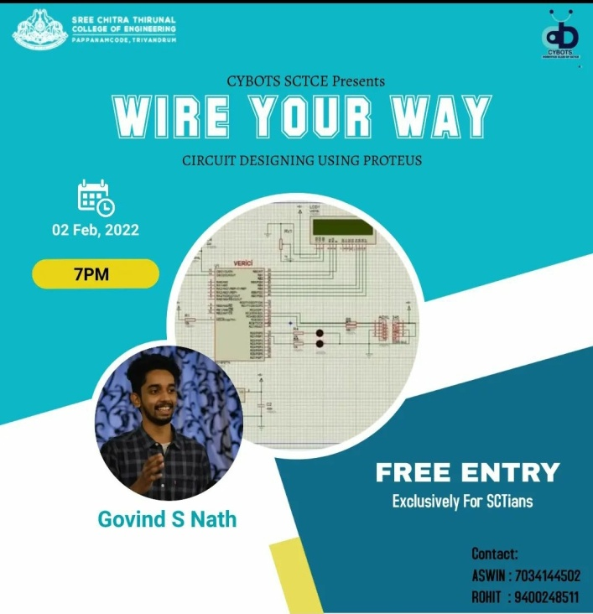

- COME FLY WITH ME

It was a 3-day online webinar organized by CYBOT SCTCE
Date: 15/02/22 to 17/02/22
Mode: Online (GMEET)
"COME FLY WITH ME" served as an introduction to drone making and the science behind it. This event was primarily for students who were interested in the field of drone making but lacked fundamental knowledge.
Total number of participants:101
DAY 1: Basics of drone, its history, and the physics behind it was discussed
DAY 2: At the second day, the session was mainly on its hardware and its application in drone.
DAY 3: At the 3rd day, the software aspects along with its integration with the above mentioned hardware was explained along with few video explanations and simulations .
Topics covered:
- Arducopter
- Multiwii
- BLDC motors
- Radio Transmitter and receiver
- Mission Planner and its simulation
- Arduino and various flight controllers such as the OPEN PILOT CC3D, KK 2.1
- Lithium Polymer Battery

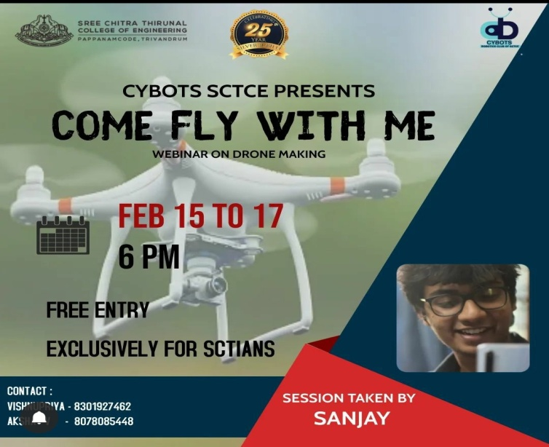

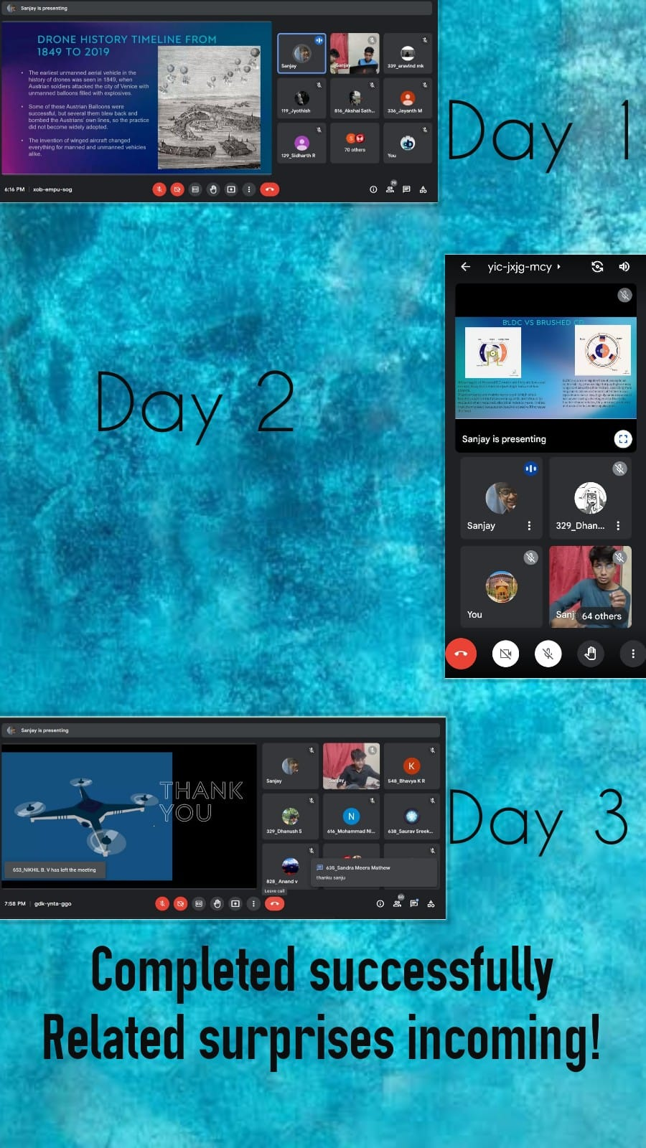

- ELECTROVENT

ELECTROVENT was a 2-day event organized by Cybots SCTCE in association with ADVENT.

DATE: 21/05/22 AND 22/05/22
MODE: OFFLINE
VENUE: ROOM NO: 205 SCTCE

The event ‘ELECTROVENT’ was conducted as a part of developing the knowledge of 3D printing and for giving a basic idea of Arduino and its programming .The main event was internet of things (IOT) by providing basic IOT kits to the participants.
Total no of teams: 4 (team of 5 to 6 members)

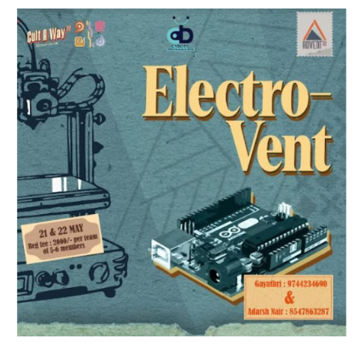

DAY 1
Time: 9:45am – 12:30pm
By the inauguration the event starts. Our first and foremost event was 3D printing and the participants were fascinated by the event .The event is designed to give a very detailed and fundamental idea on 3D printing by explaining the components.
Topics covered:
What is 3D printing?
Rapid prototyping
Intricate geometries
How does 3d printing works
Fused Deposition Modelling(FDM)
Stereo lithography(SLA)
3D design for 3D printing
Part orientation
Overhangs and arches
Interfacing with other parts
Related technologies
It was a highly interactive session with participants.
TIME : 1:30PM - 4:15PM
By using the software they all designed a model and printed with his guidance.
Students asked him about their doubts and he cleared each and everything very perfectly.

DAY 2 :
TIME: 9:30 AM – 4 :30 PM
Topics covered:
Second day, the event started by giving the basic idea of Arduino and its programming. It covered all the fundamental uses and application of Arduino. And our main event was internet of things (IOT) .This workshop focuses on the most common application of IOT starting from our home and how IOT can influence home automation .This event was conducted by providing basic IOT kits to the participants through which they can give wings to their own ideas. The workshop was highly engaging, informative and received a great response from the participants.
